I’ve decided on green and monochrome because I wanted the colors to be as least intrusive as possible when someone is reading. I wanted a color to give a calming effect as well. That’s why no bright colors are being used.

Green is also the least used colors in my Nations colors, so it won’t conflict with them.

The content area will have a very slight light grey tint to it, as grey backgrounds are easier on the eyes for extended periods of reading than white.

The color of the Ad columns will be a slightly darker grey to give it some contrast. An inner drop shadow will be used to give it the lowest visual hierarchy, and give all the good content areas to pop up.

Text will be black, because black is better for the eyes to read for extended periods of time.

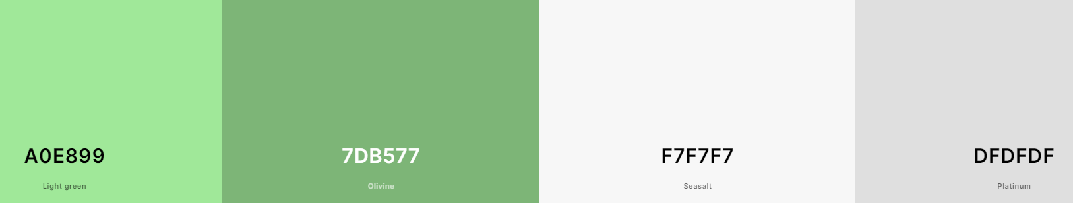

I already had the color scheme planned out before this project, so here’s a few other variations of green. Even after generating these, I’m still in favor of the original scheme.

